**Athri**

In Hinduism, Atri is a legendary bard and scholar and was one of 9 Prajapatis, a son of Brahma, said to be ancestor of some Brahmin, Prajapatis, Kshatriya and Vaishya communities who adopt Atri as their gotra. Atri is one of the Saptarishi(Seven Great Sages) in the seventh, i.e. the present Manvantara.

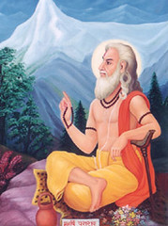

**Early Life**

Mahanirvana Tantra, translated by Arthur Avalon,(John Woodroffe), 1913, Introduction and Preface shows that The Rishi are seers who know and by their knowledge are the makers of shastra and see all mantras. The word comes from the root rish Rishati-prapnoti sarvvang mantrang jnanena pashyati sangsaraparangva, etc. The seven great Rishi or saptarshi of the first manvantara are Marichi, Atri, Angiras, Pulaha, Kratu, Pulastya and Vashishtha. In other manvantara there are other sapta-rishi. In present manvantara, the seven are Kashyapa, Atri, Vashishtha, Vishvamitra, Gautama, Jamadagni and Bharadwaja. To the Rishi the Vedas were revealed. Vyasa taught the Rigveda so revealed to Paila, the Yajurveda to Vaishampayana, the Samaveda to Jaimini, Atharvaveda to Samantu and Itihasa and Purana to Suta. The three chief classes of Rishi are the Brah-marshi, born of the mind of Brahma, the Devarshi of lower rank,and Rajarshi or Kings who became Rishis through their knowledge and austerities, such as Janaka, Ritaparna, etc. Thc Shrutarshi are makers of Shastras, as Sushruta. The Kandarshi are of the Karmakanda, such as Jaimini.

Atri Gotra originates in the lineage of Brahmarshi Atri and Anasuya Devi(Without-Spite). Anasuya is the daughter of Kardama Prajapati. Brahmarshi Atri is the seer in the fifth Mandala(chapter) of the Rigveda. Atri, also called The Devour-er represents the power of detachment. He is also the Manasa Putra and was born from the mind of Lord Brahma(from his eyes) to assist Lord Brahma in the act of creation. When the sons of Brahma were destroyed by a curse of Shiva, Atri was born again from the flames of a sacrifice performed by Brahma. His wife in both manifestations was Anasuya.

**Birth of Sons**

Anasuya’s fame and glory had spread all over the world. Indra and the devas were afraid that she might snatch their celestial treasures from them. They told the Trideva about this. The Trideva explained the greatness of Anasuya to them. But they agreed to ruin her chastity.

The Trideva took the form of beggars and came to Atri and Anasuya’s hut to beg for alms. At that time, Atri had gone to offer his daily ablutions at the river. She welcomed them and washed their feet. Anasuya was waiting for Atri took come back so they could give food to the three beggars.

But the beggars said that they couldn’t wait for the return of Atri. They demanded that the food be served right now. But they made an unusual request that she serve the food to them disrobed. Anasuya was really confident that the spiritual strength of her husband would save her, so she did so. When she entered the room, the three beggars had turned into babies.

When Atri rishi came in, he saw Anasuya with three babies. Anasuya offered the three babies at Atri’s feet. Atri realized that they were none other than the Brahma, Vishnu, and Shiva. The Trideva assumed their real forms and Atri greeted them with folded hands. The Trideva requested Anasuya to ask for a boon. She asked that Brahma, Vishnu, and Shiva actually become their children. They granted the boon and vanished. After some time, three sons were born to Atri and Anasuya: Dattatreya, Chandra, and Durvasa. Dattatreya was Vishnu, Chandra was Brahma, and Durvasa was Shiva.

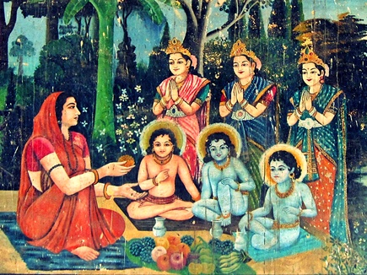

**Durvasa and Chandra Leave**

After some time, Durvasa said, “I wish to leave and go on a pilgrimage. Then I want to do severe penance.” Chandra then said, “I am going to become part of the Navagrahas. I will reside on the Moon and be the god of the Moon. Thus, you will be able to see me every night. Don’t worry, Dattatreya will remain here and combine himself with the qualities of all three of us.”

After taking the permission of their parents, Durvasa left for a long pilgrimage and Chandra left for the Moon. Dattatreya remained with Anasuya and Atri in their hermitage.

**A Sapta Rishi**

He is among the Saptarshi Mandala(seven luminous or eternal sages in the sky) symbolized by the Great Bear(or "Ursa Major" in Latin) and the seven stars around it, named Megrez in Arabic(the root of the tail). The star is also considered as δ(Delta) or the 4th star in the Great Bear constellation. Saptarshi, among several meanings, are described as "The seven solar rays"(Sapta-rishayaha) by the Rishi Yaska. Collectively, they are also called Pitarah, the Fathers.

Atri, who was born from Brahma's eyes and the Vishnu-Dharma, is said to rule the other stars of the Great Bear identifying Kratu with the star α Dubhe; Pulaha with β Merak; Pulastya with γ Phecda; Atri with δ Megrez; Angiras with ε Alioth; Vasishtha with ζ Mizar; Bhrigu with η Alkaid. According to the Puranic stories, Brahma went into deep meditation for several thousands of years, at the termination of which a drop of water fell from his eyes which took the form of the sage, Atri.

**Seer Of Rig Veda**

He is the seer of the fifth Mandala(Book 5) of the Rigveda. Atri had many sons and disciples who have also contributed in the compilation of the Rig Veda and other Vedic texts. Mandala 5 comprises 87 hymns, mainly to Agni and Indra, but also to the Visvedevas("all the gods'), the Maruts, the twin-deity Mitra-Varuna and the Asvins.

Two hymns each are dedicated to Ushas(the dawn) and to Savitr. Most hymns in this book are attributed to the Atri clan composers.

**His Role In Ramayana**

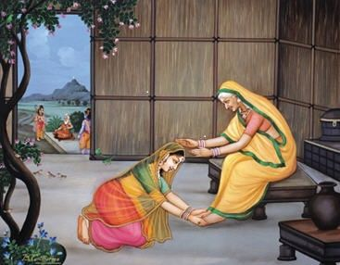In the Ramayana, during their exile, Rama, Lakshmana, and Sita visited Sage Atri and Anasuya’s ashram. They reached the hermitage and offered salutations to Atri and Anasuya.

Atri urged Sita to meet Anasuya. Anasuya instructs Sita how to be a devoted wife. She also talks about the roles and responsibilities of a wife.

After staying the night at Sage Atri’s hermitage, Sita, Lakshmana, and Rama take departure of the hermitage.

**His Role In Mahabharata**

He had a close connection with Mahabharata. Drona was the head of the Kaurava army after Bhishma's fall. Dronacharya fought ferociously. The wounded and the dead soldiers were in the thousands. Their cry of pain rent the skies. Blood flowed on the battlefield. Dead bodies piled up and provided the food for the birds of prey. In this carnage which went beyond all human estimation, Drona stood like a mad hero of demonic proportion.

Sage Atri was very worried because if Drona continued this he would cause destruction and human misery beyond proportions, Atri and Gautama Maharishi came to the battlefield along with five of their companions. It was at this time Yudhishtira had shouted at the instance of Sri Krishna saying that Ashwathama was killed so as to discourage Drona from fighting any longer, which is widely regarded as one of the most cowardly acts in the entire Mahabharata. This put Drona off completely. He lost all hope in his life. He became mad with anger. This sent danger signal all around.

Sage Atri felt sad for him and talked to him in a friendly manner, consoling him.

**TrinityTest Of Anasuya**

Once trinity decided to test the chastity of Anasuya. They came to Anasuyaa's house as Brahmins and request for food with the condition that she has to serve it nude. Anasuyaa without any hesitation agreed to that. In turn she used her pativrita shakti to convert the Brahmins into child and offered them food without any dress. Trinity could revert to their original form only after she did herself on the request of gods. Trinity blessed them with three sons being sons: Dattatreya, Soma or Chandraatri and Krishnaatri or Durvasa.

Rama, the son of Dasharatha, visited Atri Maharishi's Ashram during his fourteen years of stay in the forest. It was Atri who showed the way to Dandakaranya forest to Rama, after showering his hospitality on him.

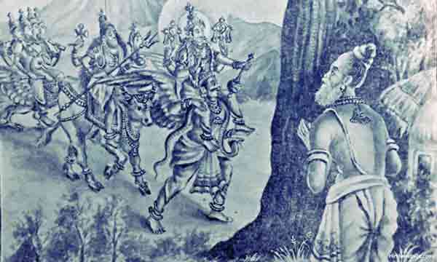

Atri Maharishi is considered to be one of the great discoverers of sacred Mantras of Hinduism. In his family line there were a few other seers of mantras namely: Shaavaashva, Avishtir and Purvaatithi. There were also other great Rishis in that line: Mudgala, Uddaalaki, Shaakalaayani, Chaandogya, etc.

Atri-samhita and Atri-smriti are two works attributed to Atri.

Till the present day, a number of Brahmin families have this sage's name at the head of their lineage, which indicates that he or his descendents tutored that whole lineage.